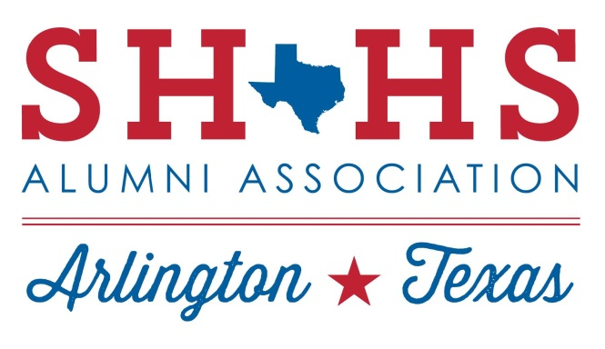
P.O. Box 152742
Arlington, TX 76015
www.shhstexans.org

Non-Discrimination Policy
Sam Houston High School Alumni Association’s purpose is to provide support to the students, faculty, staff, and administration of Sam Houston High School to promote success, spirit, and pride and improve student educational outcomes.
Given its mission, the SHHS Alumni Association has adopted this Non-Discrimination Policy to guide its board members, volunteers, members, and attendees in their conduct when acting on behalf of the SHHS Alumni Association.

Non-Discrimination
The SHHS Alumni Association is committed to providing a welcoming and inclusive environment for all individuals, regardless of race, color, religion, sex, national origin, age, disability, sexual orientation, gender identity, or any other protected characteristic. We believe that diversity enriches our organization and enhances the quality of our programs and services.
As an organization dedicated to supporting the students, faculty, and staff of Sam Houston High School, we value and respect the unique perspectives, experiences, and backgrounds of all individuals associated with our organization, including students, volunteers, teachers & faculty, and partners.
Discrimination, harassment, or any form of disrespectful behavior based on race, color, religion, sex, national origin, age, disability, sexual orientation, gender identity, or any other protected characteristic is strictly prohibited at SHHS Alumni Association. This policy applies to all aspects of our operations, including but not limited to members, volunteers, events, programs, scholarships, and other services.
We are committed to fostering an inclusive culture that promotes equal opportunities and fair treatment for everyone. Our organization will not tolerate any form of discrimination or harassment, and appropriate measures will be taken to address and rectify any violations of this policy.

If any individual associated with SHHS Alumni Association believes they have experienced discrimination or harassment, they are encouraged to report the incident promptly to any board member. Reports will be treated confidentially and will be thoroughly investigated. Retaliation against individuals who make good faith reports of discrimination or harassment is strictly prohibited.
To ensure the effectiveness of this policy, SHHS Alumni Association will provide regular training and education on diversity, equity, and inclusion to all members and volunteers. We will also review and update this policy periodically to ensure its alignment with legal requirements and best practices.
By fostering a diverse and inclusive environment, we aim to create a community where all individuals feel valued, respected, and able to contribute their unique talents and perspectives to the success of our organization.
Our mission is to encourage diversity:
Support equal opportunity, regardless of race, color, sex, religion, national origin, age, disability, genetic information, marital status, pregnancy, gender identity or expression, sexual orientation, ancestry, veteran status, citizenship, health condition or other protected status.
Provide a genuine opportunity to all qualified applicants for board member, member or volunteer positions.
Zero tolerance for discrimination or harassment of others.

Code of Conduct
Please review our Code of Conduct at www.shhstexans.org/documents.

Social Media Policy
Please review our Social Media Policy at www.shhstexans.org/documents.

Compliance
By participating with, and therefore being a representative of the SHHS Alumni Association, you are agreeing to abide by this policy.

Consequences
SHHS Alumni Association reserves the right to remove a member (including board members) and relieve them of duties if they violate these rules.
Questions or concerns may be addressed to the board by sending an email to info@shhstexans.org.

